The Frame

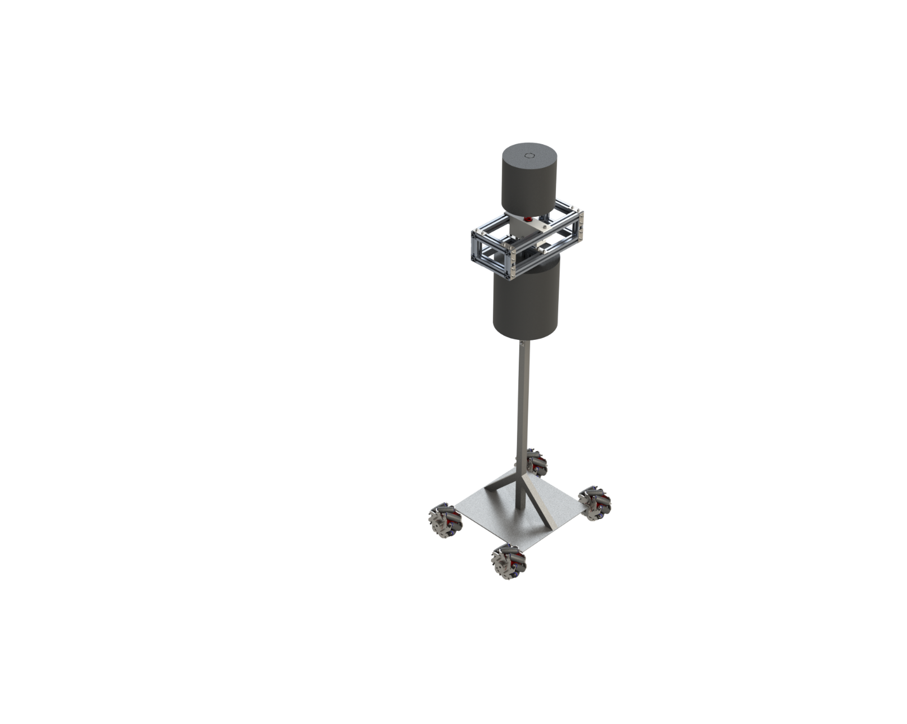

Selecting the Spring
There are four ways to select the spring we can use for the head of the robot: using mathematical formulas, carrying out a FEA on a 3D model, through real-life experiments, or looking for springs used in similar applications.

Mathematical formulas
There exist mathematical formulas to evaluate springs and how they would behave when they are loaded. We can make various calculations for springs loaded in compression, tension, or torsion. In our application, however, there exists a problem: our spring is being loaded laterally. The force applied to the spring is perpendicular to the axis of the spring. Laterally loading a spring is a non-standard practice, as such there are no derived formulas for working with such loads applied on a spring and the math is simply too complicated.

Finite Element Analysis (FEA)
We could create a 3D model of a spring and conduct a FEA. We can adjust the spring properties like the coil diameter and the number of coils, we can adjust the magnitude and type of the force we want to apply, and more importantly, we can load the spring laterally to see how it would behave. Using this method for spring selection, the team faced a problem: unexpected spring behaviour. When a spring experiences a lateral impact force, like a punch, it will deflect laterally, then rebound in the opposite direction, towards the boxer, at a reduced rate. It is important to consider this rebound when selecting a spring because we do not want the spring to rebound too much towards the boxer and end up hurting them. However, in simulations, the rebound is not observed; simulations simply treat the spring like a vertical beam. As result, the spring ends up being permanently deformed to the side due to the impact force with no rebound.
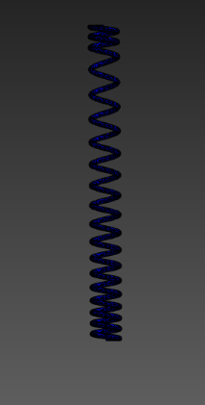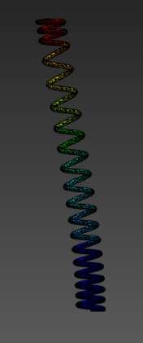
Figure 1: Spring Deflection Simulation using ANSYS

Experiments
Ideally, the best way to select a spring for lateral loading is to conduct a series of experiments with springs of varying lengths and stiffnesses to identify the best one for our application. This problem with this, however, is the budget and time constraint. Large springs, like the ones we require for our application, are too expensive to purchase multiple of. To add on to that, once the experiment is concluded and the right spring is selected, the remaining springs are essentially useless to us. Even if we can work past the budget constraint, it will take time to set up and conduct the experiments. While the time constraint is not too massive of an obstacle, it is still worth considering.

Used in similar applications
The last method of selecting a suitable spring is possibly the most realistic and viable method of them all since the team has faced major obstacles with every other method thus far. This method is quite simple: look for springs used in a similar application to ours and select that spring. After some research, the team has identified the “Kewlus KS2 Spring” as the best option. It is used in DIY punching bags and is subjected to the same lateral load as our application.
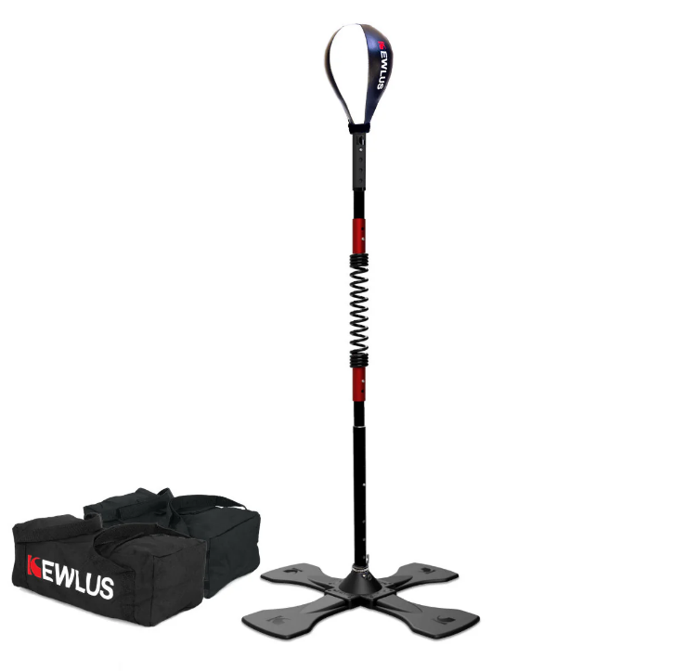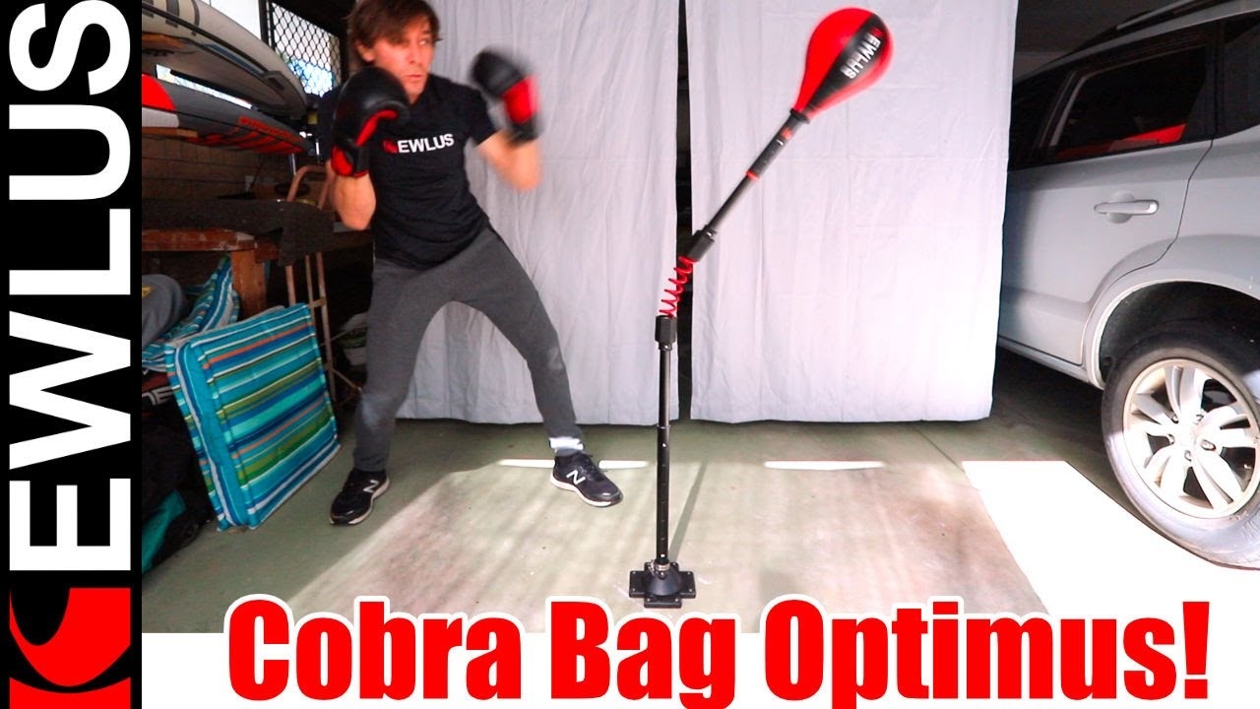
Figure 2: Kewlus KS-2 Spring used in a DIY punching bag and its lateral load application
Kewlus also offers a heavy-duty version – the KS3 Spring – but since we will be layering the spring with cushion/foam to protect the user’s hands, the force transmitted onto the spring is not that great, and so the team has decided the basic spring is sufficient for our application.

Evaluating max force to be exerted on spring
Upon selecting the spring, we need to evaluate the maximum force to be exerted on the spring to evaluate how much foam we need around the spring to achieve this. The factor we are trying to optimize is the rebound. We want to set a rebound limit to prevent the spring from rebounding too much and hitting the user, then analyse how much force the spring can take before reaching this rebound limit. The problem once again is that this is very difficult to analyse without a real-life study. Since we do not have the time to wait for the spring to arrive, then conduct a study and figure out the thickness of foam we need, we need an alternative method. Simulations seem to be the best alternative method we have. However, since rebound is not simulated in a FEA, we will assume that it is equal to the lateral displacement caused by the punch with no force dissipated/absorbed by the spring.
We will set the rebound limit to be the width of the robot’s shoulder because if the spring rebounds out of that limit, it will be in the space of the user. According to an anthropometric study on the human chest, we can derive the average chest depth of males to be ~200mm [1]. We can use the chest depth to dimension the robot’s shoulder width because our robot does not have a “chest”, which is instead replaced by foam around the vertical support.
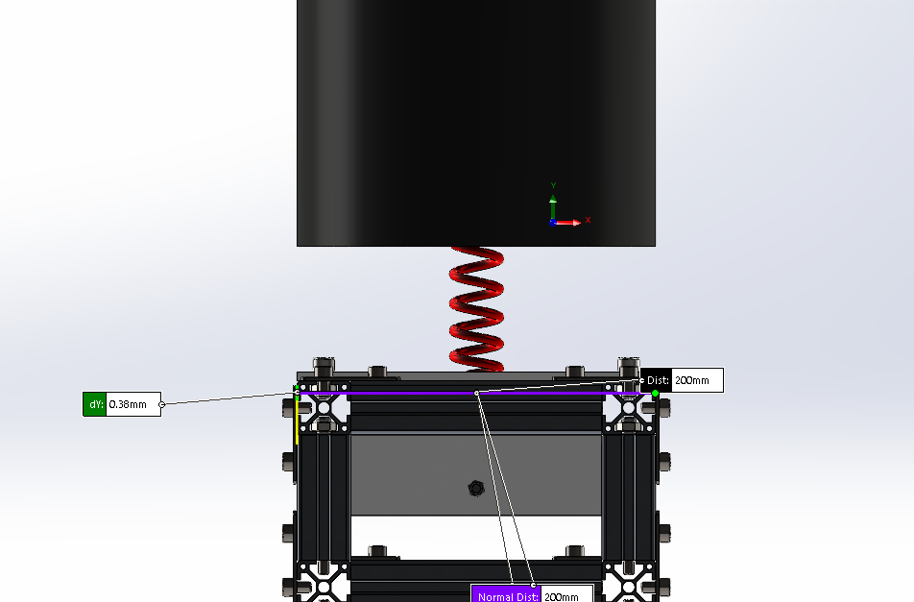
Figure 3: Width of the robot’s “shoulder”

Since the spring is mounted on the center of the shoulder, the maximum deflection will be 100mm.
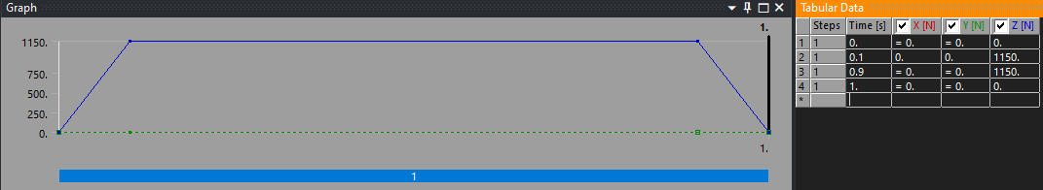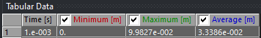
Figure 4: Outcome of spring simulation. Maximum deflection: 0.098m (~100mm), Force applied: 1150N
The result of the simulation suggests that a ~1150N force causes ~100mm deflection. We will include a safety factor of 1.5 just to be on the safe side, making the final force ~766N, which can be rounded to 750N.

Calculating thickness of foam around spring to achieve max force
We now know the maximum force to be exerted on the spring is 750N. We also know the force of a boxer’s punch is about 2500N [2]. We need to calculate the thickness of the foam we need around the spring to achieve this. But first, we need to identity the type of foam to use. We can draw inspiration from existing boxing training solutions. The patent documentations of Liteboxer reveal that the foam used is EVA Foam [3]. More research reveals that EVA foam is great at absorbing impact without rebounding, making it ideal for our application. The amount of force EVA foam can absorb depends on both its thickness and its density. The density of EVA foam generally varies between 50 and 300 kg/m³ [4]. A study was conducted by a group of researchers from the Shaanxi University of Science & Technology to understand the mechanical behaviour of EVA foam under compression [5]. Since only properties of 5 foam densities is available from this study, we choose one to work with.
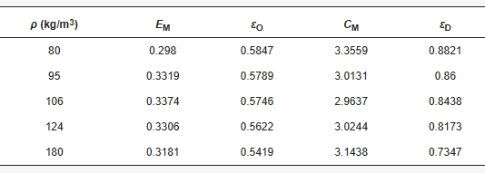
Figure 5: Maximum energy absorption capacity (E_{M}) of EVA foams of varying densities
As shown in the figure above, the energy absorption efficiency decreases the denser the foam gets. We choose the foam with 95 kg/m³ density because it is the highest round number that offers the highest energy absorption efficiency; foam with round number densities will be easier to find and procure.
This study was conducted with foam specimens of 30mm thickness. If we apply a 1000N force, the foam will absorb 33.19% of the force, producing a resultant force of ~670N. If we stack the 30mm foam on top of another 30mm foam, the first layer will absorb 33.19% of the 1000N force, applying ~670N to the next layer, which will then absorb 33.19% of the 670N force, producing a resultant force of ~450N. Using this logic, we can calculate that we need 95 kg/m³ foam of 90mm (3 x 30mm) thickness to reduce a 2500N force to 750N (2500 * 0.6681 * 0.6681 * 0.6681 = 745N).

Steel base and supports (Redundant)
Having too much of weight up top will make the robot unstable and susceptible to toppling. To shift the center of gravity down, we want to make the base heavier. This can be achieved simply by adding counterweights at the bottom. However, adding weights just for the sake of adding weights is not efficient. We can make the base heavier in other ways, reducing the need for a heavy counterweight. Firstly, we use a lighter material for the top of the robot and a heavier material for the bottom. Working under a budget, the two best candidates for this would be aluminium and steel. Making the top half of the frame out of aluminium and the bottom half out of steel will keep the center of gravity low. We can even add angular steel support to the front and back of the vertical support with a two-fold purpose: to bring the center of gravity even lower and provide additional support to the vertical support. These angular supports will reduce the stress exerted on the connection between the vertical support and the base as shown in the previous section. For the top half of the robot, we use basic t-slot aluminium extrudes to retain the high strength-to-weight ratio of aluminium while making it easy to assemble and disassemble if needed. For the bottom half of the robot, we can use steel beams with a square profile. The angular supports will attach to the vertical support at an angle of 45°. An equilateral triangle can support a higher load [6] but we want to keep the CG low, so we use the second-best option, the right-angle triangle. Two right-angle triangles provide the best balance between supporting the vertical beam and keeping the CG low.
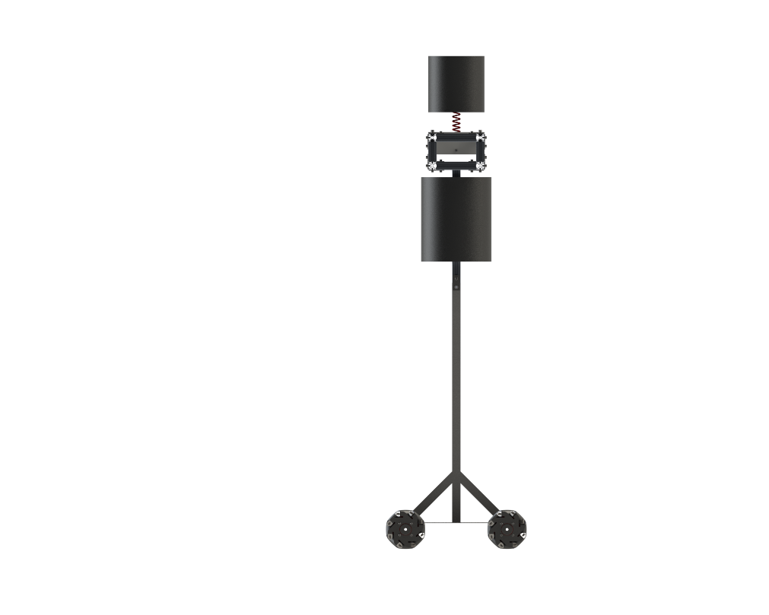
Figure 6: Side profile of BoxBunny, showcasing the 45° angular steel supports at the base.

Key Dimensions

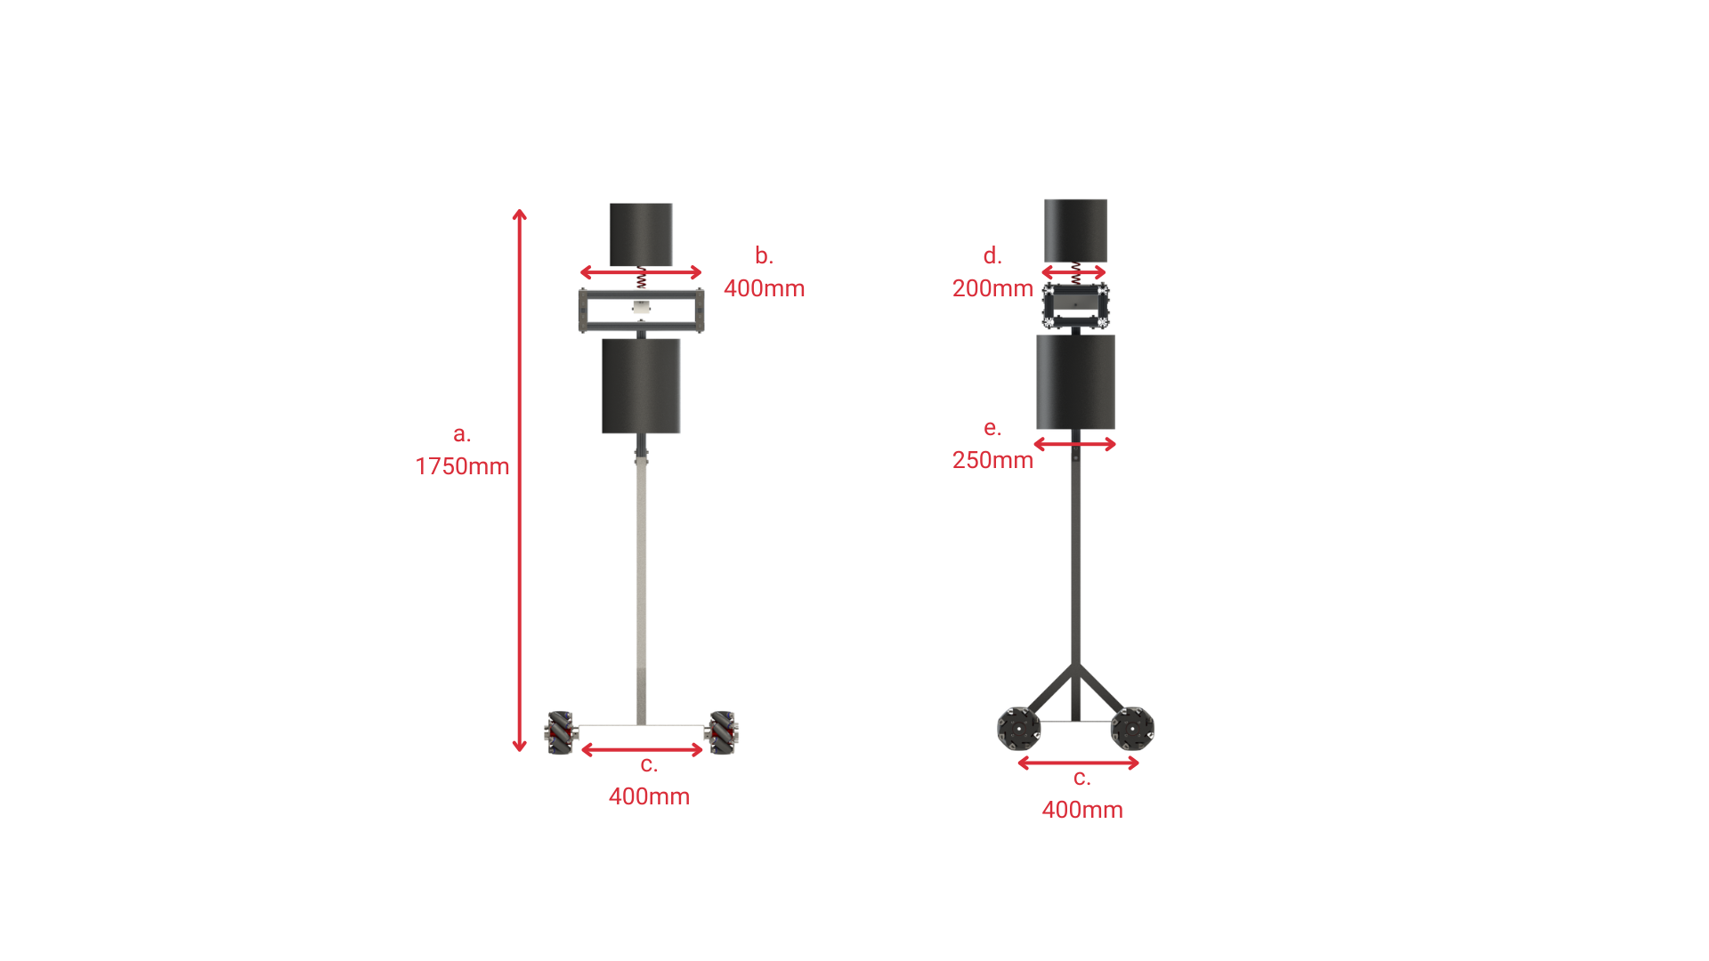
Figure 7: Key dimensions of BoxBunny
a. The robot's height from “head” to “toe” is the average height of a human male. [7]
b. The shoulder width of the human is the average biacromial (shoulder) width of a human male. [8]
c. “Standing shoulder width apart” - the width of the base is the same as the shoulder’s width. The base is a square.
d. The shoulder of the robot is the average chest depth of a human male since the robot does not have a “chest”. [1]
e. The thickness of the foam around the vertical support is just enough to protrude from the shoulder thickness to prevent the user from accidentally striking the aluminium profiles that make up the shoulder assembly.

Battery Placement and Center of Mass
Placed underneath, on left side, centered back-to-front
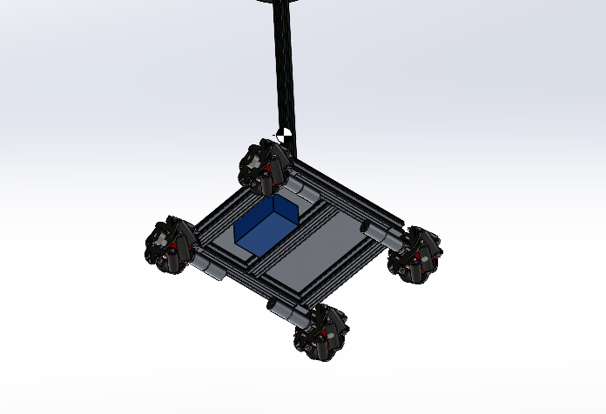
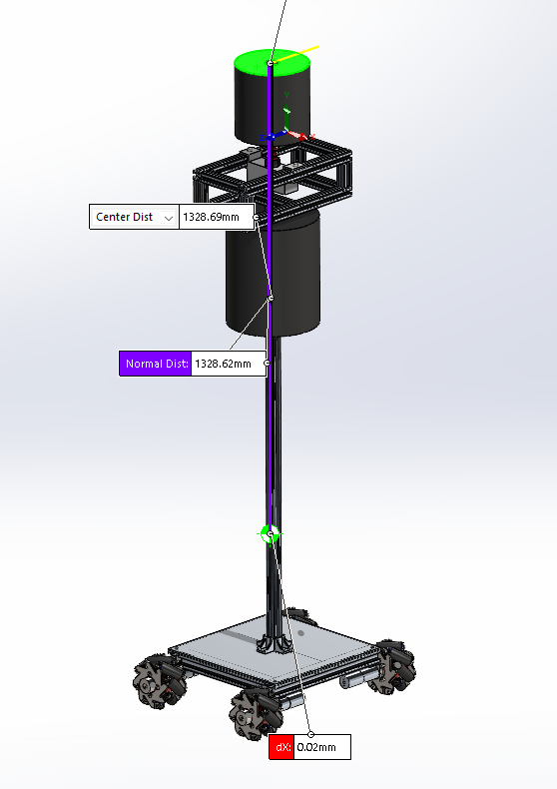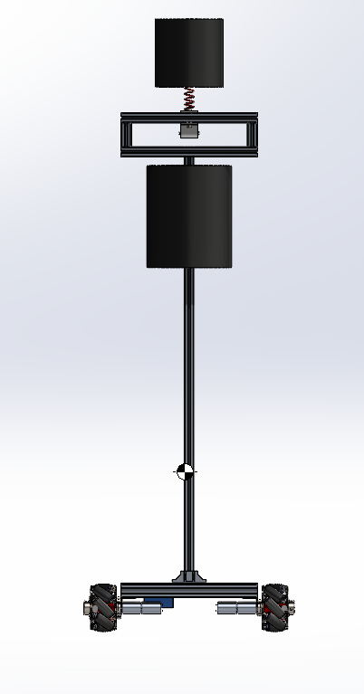

Placed on top, centered left-to-right, towards the front of the robot for counterweight efficiency
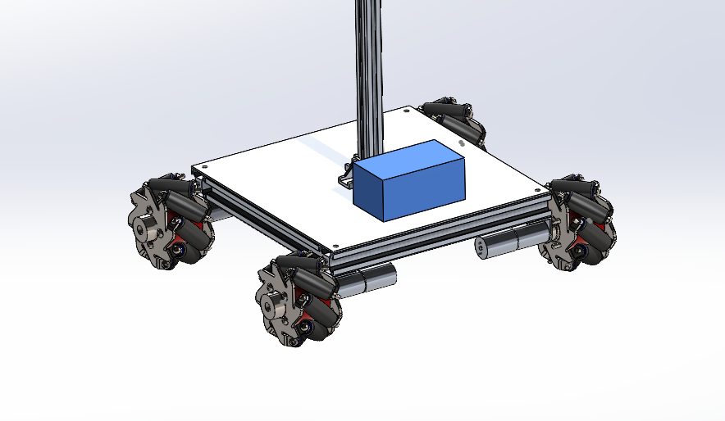
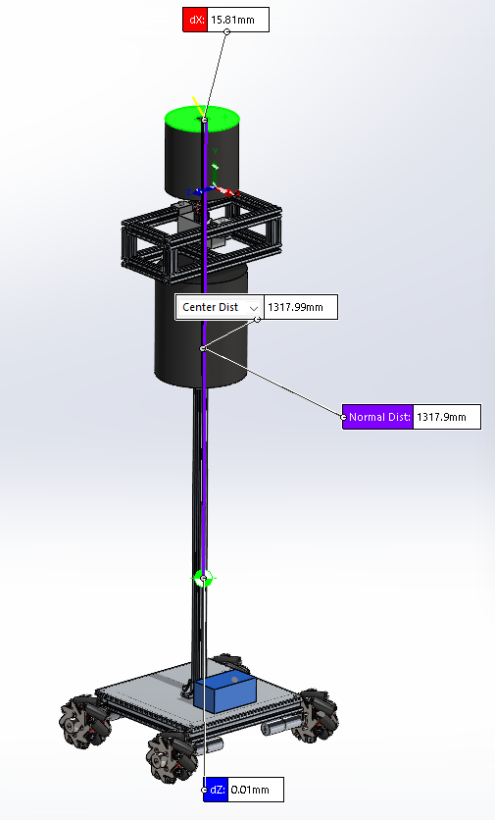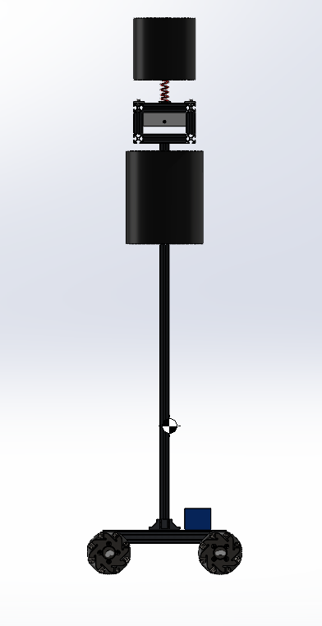

Foam Holders
https://3dchimera.com/blogs/connecting-the-dots/3d-printing-tolerances-fits?srsltid=AfmBOoqmnX-Os_RRy-dUfn7z_avNlVLlTzG2welNoCS5uiTnn2loY9Ot

8.Base Battery and Electronics Layout
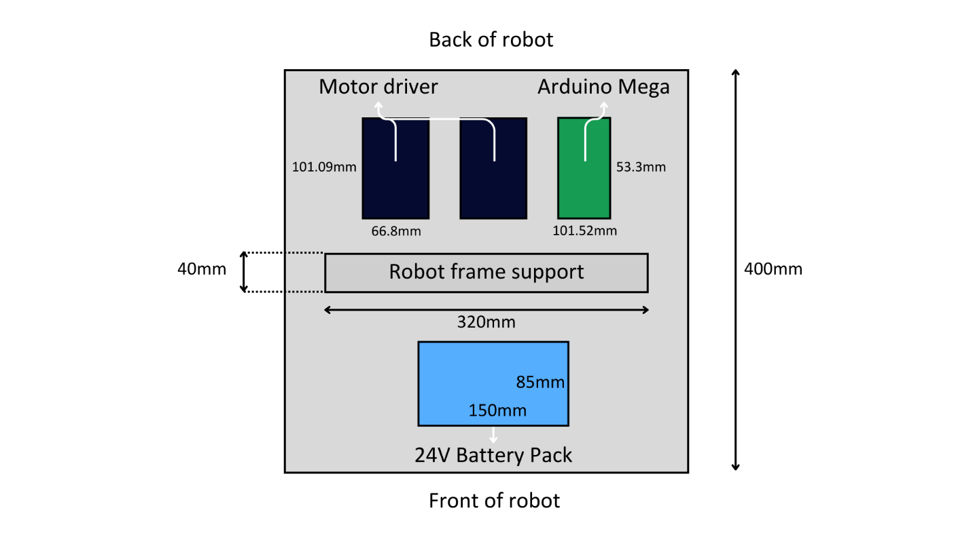
[will have to edit to add the MPU9250 and breadboard]
The battery pack (weigh ??) powering the mecanum wheels is placed in the middle of the front half of the wheelbase to contribute to the robot’s stability during a forward punch by the boxer. This is preferred over other possible layouts like one battery pack on either side of the wheelbase for equal weight distribution or the battery pack on the back half of the wheelbase which decreases its stability during a punch.
The electronics will be equally spaced apart in the middle of the back half of the wheelbase. This results in more efficient wiring to the Arduino controller and wheel motors under the wheelbase.

References
[1] Meacham, H. (n.d.). Chapter 2, Section 20. Onlin Anthropometry. Retrieved from http://personal.cityu.edu.hk/meachan/Online%20Anthropometry/Chapter2/Ch2-20.htm.
[2] Boxing Science. (n.d.). Punch Force - The Science Behind The Punch. Retrieved from https://boxingscience.co.uk/punch-force-science-behind-the-punch.
[3] Bains, E.M. (2022). Interactive exercise and training system. U.S. Patent US11534673B2.
[4] Wang, J., Xu, H., & Zhang, Y. (2020). Performance of ethylene-vinyl acetate foam as cushioning material for rigid debris-resisting barriers. ResearchGate. Retrieved from https://www.researchgate.net/publication/342222938_Performance_of_ethylene-vinyl_acetate_foam_as_cushioning_material_for_rigid_debris-resisting_barriers.
[5] Zhang, H., Liu, Y., & Zhang, Z. (2019). Mechanical Behavior of Closed-Cell Ethylene-Vinyl Acetate Foam under Compression. Polymers, 11(4), 659. Retrieved from https://www.mdpi.com/2073-4360/11/4/659.
[6] Narayanan, S. (2017). Investigating the Effectiveness of Different Materials for Protection Against Falling Debris. Retrieved from https://csef.usc.edu/History/2017/Projects/S0314.pdf.
[7] Meachan, H. (n.d.). Chapter 2, Section 1. Online Anthropometry. Retrieved from http://personal.cityu.edu.hk/meachan/online%20anthropometry/chapter2/Ch2-1.htm
[8] Meachan, H. (n.d.). Chapter 2, Section 18. Online Anthropometry. Retrived from http://personal.cityu.edu.hk/meachan/Online%20Anthropometry/Chapter2/Ch2-18.htm

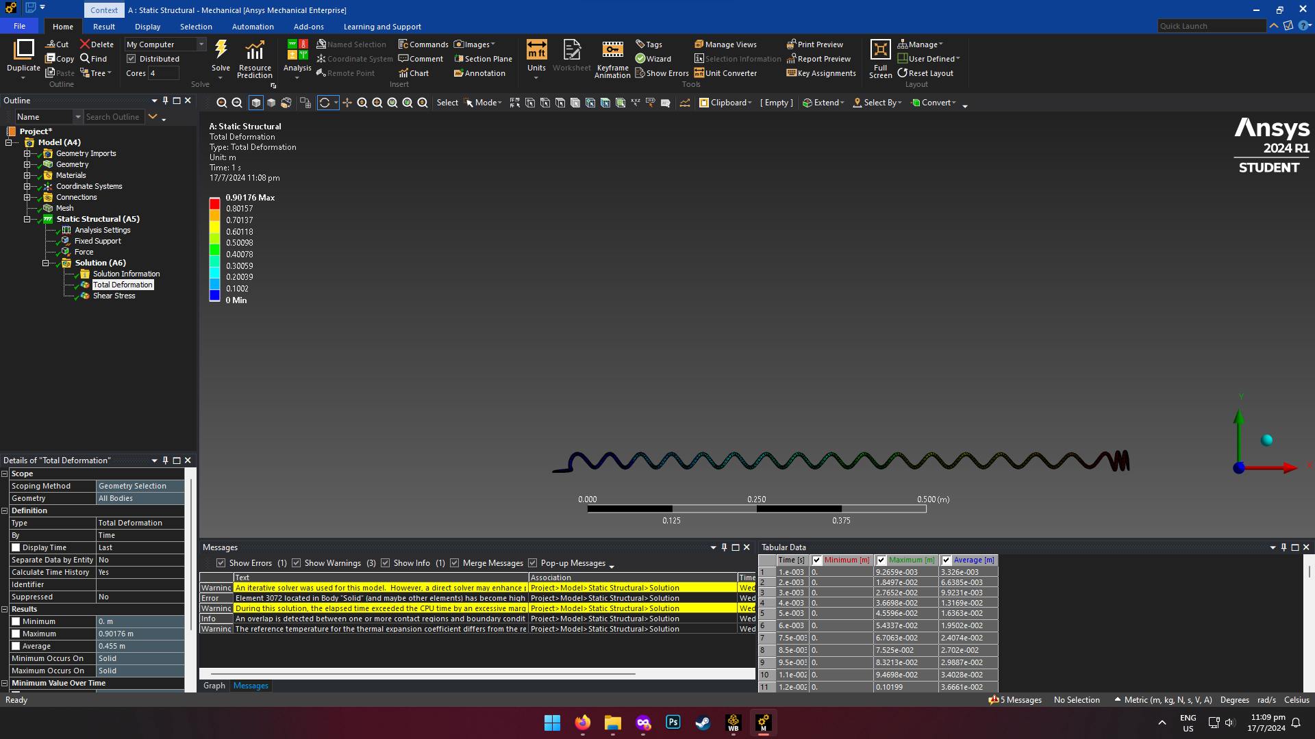
Help

